Smart TV User Guide

This user guide will help you navigate and take advantage of all the features on the Satellite TV.

Introduction:

The satellite TV receiver box is called a Sky Set Top Box, and it comes with a Sky Remote.
It is a satellite TV receiver that is used to receive Freesat TV. We chose to use a Sky Box and remote because they are very common and most people are already familiar with them.

Using the Sky Box and remote:
Sky Box remote control:
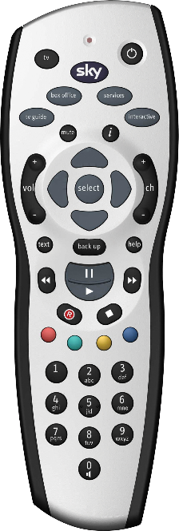
First you must switch on the Sky Box. To do so, please use the remote depicted here on the right, and press the top right circular button 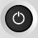. You will notice that a green light will light up on the Sky Box. Now the Sky Box is on, you need to select the channel you wish to watch. To do this please press the TV Guide 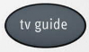 button.

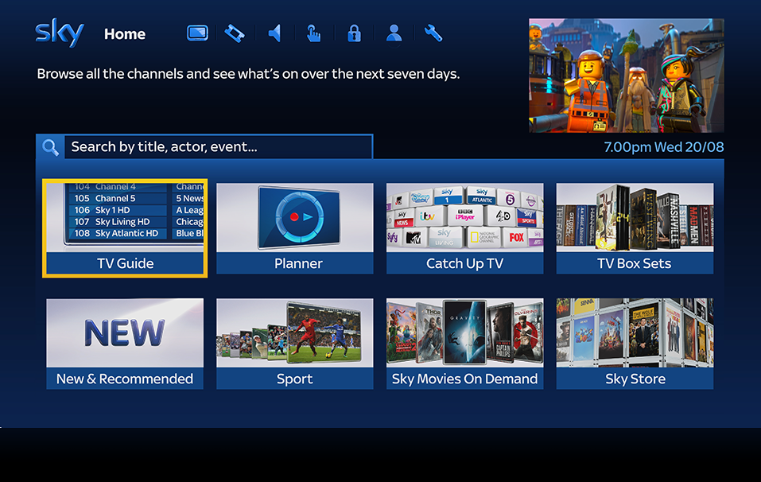
You will see this screen:

Now press the select button to enter the TV Guide channel listings. Note how the TV Guide option is already highlighted in a yellow frame. This is how you know which menu item will be selected when you press the select button.

In order to move to another menu item, please use the cursors, or arrows on the remote, and once you’ve highlighted the menu item of your choice, then press the select button as before.

Once you’ve selected TV Guide, the menu will change to show the All Channels listing, like this:
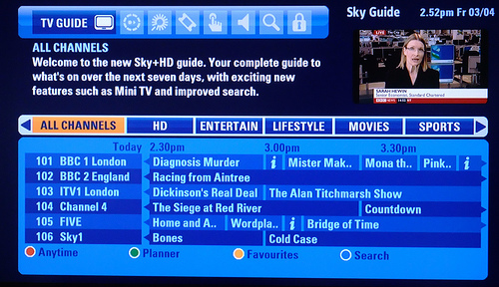
You can now press the select button to go into the all channels listing. You will see the yellow highlighted area move down to the first channel in the listing. You can then use down and up arrows on the remote to scroll through the various channels. Once you’ve found a channel you like, press select to show a preview on the top right, and press select a second time to go leave the menu and enter the channel completely in full screen.

Recharging the Sky Box remote control batteries:

If the Sky Box remote control is unresponsive, it may need its batteries recharged. To remove the batteries please remove the back cover first. Removing the back cover is done by pulling on the small tab at the bottom of the remote. There are spare rechargeable batteries in the drawer below the TV that should be fully charged. Place them into the remote and replace the cover. The empty batteries need to be recharged before placing in the drawer. The batteries will take about 4 hours to recharge. Once the 4 hours are up, simply remove the batteries from the charger and place them into the drawer.

List of channels available:

Due to our remote location from Britain unfortunately there is a lower signal, some channels will work, and others won’t. The weather can also affect this, but there is an extensive list of channels for you to watch:

Satellite TV Channel List:
Nr: | Channel:
134 | S4C
145 | Challenge
146 | CBS Reality
147 | CBS Reality +1
148 | CBS Action
149 | CBS Drama
152 | Pick
153 | Pick +1
164 | Challenge +1
182 | BEN
183 | True Drama
184 | True Ent
185 | more>movies
186 | m>movies +1
187 | BET:BlackEntTv
189 | propeller
190 | BET +1
191 | Showcase
192 | Showcase 2
198 | Reality TV
199 | OH TV
203 | My Channel
209 | Africa Channel
212 | Information TV
218 | Vox Africa
251 | Food Network
252 | Travel Channel
262 | Food Network +1
263 | Travel Ch +1
280 | Horse & Country
281 | The Active Ch
282 | FAB TV
284 | holiday+cruise
290 | ABN TV
292 | Film On. Tv
293 | Showcase 2 +1
295 | Info TV +1
319 | horror channel
320 | horror channel +1
321 | True Movies 1
322 | True Movies 2
325 | movies4men
326 | movies4men +1
357 | VIVA
359 | The Box
361 | KISS
362 | Smash Hits!
363 | Magic
364 | Heat
365 | Chart Show TV
366 | The Vault
367 | Scuzz
368 | Kerrang!
369 | Vintage TV
370 | Planet Pop
371 | Starz TV
372 | Chartshw Dnce
374 | Flava
376 | 21stCent Bliss
378 | NOW Music
383 | Clubland TV
385 | Channel AKA
387 | Heart TV
388 | CAPITAL TV
501 | Sky News
505 | CNBC
506 | CNN
508 | Euronews
510 | CCTV News
512 | RT
514 | Al Jazeera Eng
517 | eNCA Africa
519 | ARISE News
539 | Community
571 | BON TV
572 | TVC News
573 | News 18 India
580 | GOD Channel
581 | revelation
583 | TBN Europe
584 | DAYSTAR
585 | UCB TV
586 | LOVEWORLD TV
587 | Inspiration
588 | Gospel Channel
589 | EWTN
590 | World Network
591 | Faith World TV
592 | KICC TV
593 | Believe TV

